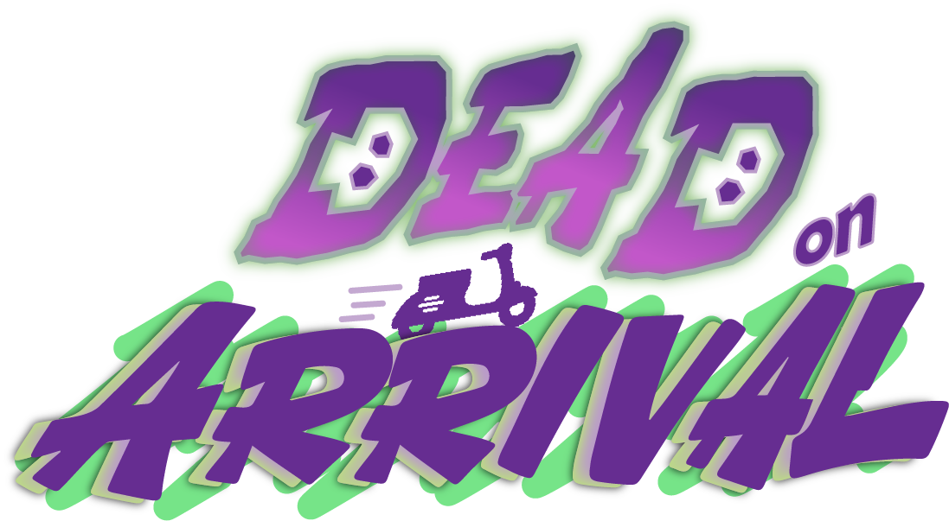
Technical Design Document
November 2026 | Version 3.0 | The Boo Crew

Table Of Contents
Document Status
Game Engine
Additional Software
Tools
Technical Goals
Concerns
Display
Match Flow
Gameplay Mechanics
Order Game Objects
Order Manager
Golden Order
Holding Orders
Order Arrows
Driving
Sphere Driving
Acceleration/Braking
Motion and Steering
Reversing
Drifting
Slipstream
Phase Boosting
Stealing Orders
Phasing Through Buildings
Scoring
Respawning
Emote System
Final Order Sequence
Game Modes and Match Rules
Bots
Highlight Reel
Results
Player Management
Player Spawning
Player Input
Player Score
Online Multiplayer
Architecture
What Syncs and How
Online Safety
Steam Integration
Localization
Settings Files
World Mechanics
Boost Pads
Grass
Moving Objects
Pedestrians and Props
Scene Management
Persistent Scene
Asynchronous Loading
VFX and Shaders
Player Trails
Sound and Audio
Cinematics
Performance
File Structure
Hot Keys
Testing
Coding Guidelines
Classes
Variables
Constants
Getter/ Setter Methods
Serialize Field and ToolTips
Method Summary
Whitespace
Coroutines
Testable Rules
Full Example Code
Build Delivery Method
Repo Policy
Related Documents
Revision History

Document Status
This document describes how the game is built today, as of the Steam build on branch steam-phase1a. What the game is and why is in the separate Game Design Document (GDD). Longer per-system notes live beside the code, in the repo's docs folder (see Related Documents).

Game Engine
Our game engine is Unity 2022.3.62f3 LTS (upgraded from 2022.3.7f1 in September 2026), in C#. The project stays on 2022.3: Netcode for GameObjects 2.x needs Unity 6. 2022.3.62f2 or later is also required for the CVE-2025-59489 runtime fix, so only ship builds made with a patched editor.

Additional Software
- 3DS Max 2023
- Blender (also run headless for key art and FBX fixes)
- Photoshop
- Substance Painter
- Hansoft (2023-24 team production only)
- GitHub / GitHub Desktop
- Steamworks SDK and steamcmd (uploads only, kept outside the repo)
- Python (tools folder: strings, icons, art, compile check, App ID)
- .NET SDK (quick compile check without Unity)

Tools
Package | Version | Used for
Universal Render Pipeline, Shader Graph, VFX Graph | 14.0.12 | Rendering, shaders, effects
Input System | 1.14.0 | Controllers and keyboard, rebinding
Cinemachine | in Assets/Cinemachine | Player and cutscene cameras
Timeline | 1.7.7 | Cutscenes
Text Mesh Pro | 3.0.7 | All UI text
AI Navigation | 1.1.6 | Scooter NavMesh for bots
Netcode for GameObjects | 1.15.1 | Online multiplayer
Unity Transport | 1.5.0 | Direct sessions, editor and LAN only
SteamNetworkingSockets transport | embedded, patched copy of d862504b | Online sessions over Steam (Packages folder, see CHANGES-DOA.md)
Steamworks.NET | 2025.164.1 (SDK 1.64) | Steam API. Never copy SDK 1.65 DLLs into Assets
ParrelSync | 1.5.3 | Two editors on one PC (editor only)
DOTween | Plugins | Small motion tweens
OToon | Assets | URP toon shading

Technical Goals
Goal | Status
Complex driving system | Done
Successful phase boost system | Done
Smooth performance with 4 player split screen | Code work done. Target is 120 FPS. Editor settings changes and real hardware measurements still to do (docs/performance.md)
Online play that leaves local play untouched | Done. Nothing online runs unless a player picks it
Automated test cover | About 1,500 EditMode tests, including a scripted 4-player match

Concerns
- The Camera
  - Phasing is resolved: it works by swapping what the view renders. The 2023 concern about backing into a wall has no dedicated code, so check it in a playtest
- Performance Issues with Split Screen
  - Partly resolved: views under full-screen cameras stop rendering, and quality scales with player count. The biggest gain left is switching the players' renderers from Deferred to Forward, which is an unverified editor change
- Online without host-side movement checks
  - Each machine drives its own scooter, so a modified game can cheat with its own. Accepted for now. Safety of other players is covered (see Online Safety)
- Hand testing has lagged the code
  - Recent features pass automated tests but have not had a hand playtest (EDITOR-TODO.md)
- Only Windows has been played
  - macOS and Linux build cleanly but are untested. The macOS build is made on Windows, so it is unsigned

Display
Our game is displayed in split-screen with up to four views. Each player's camera renders to its own viewport. PlayerCameraResizer sets them up, and SplitScreenLayout decides the rects: with two players, the Split-screen option picks boxed, stacked or side by side. Below is the four-player layout.
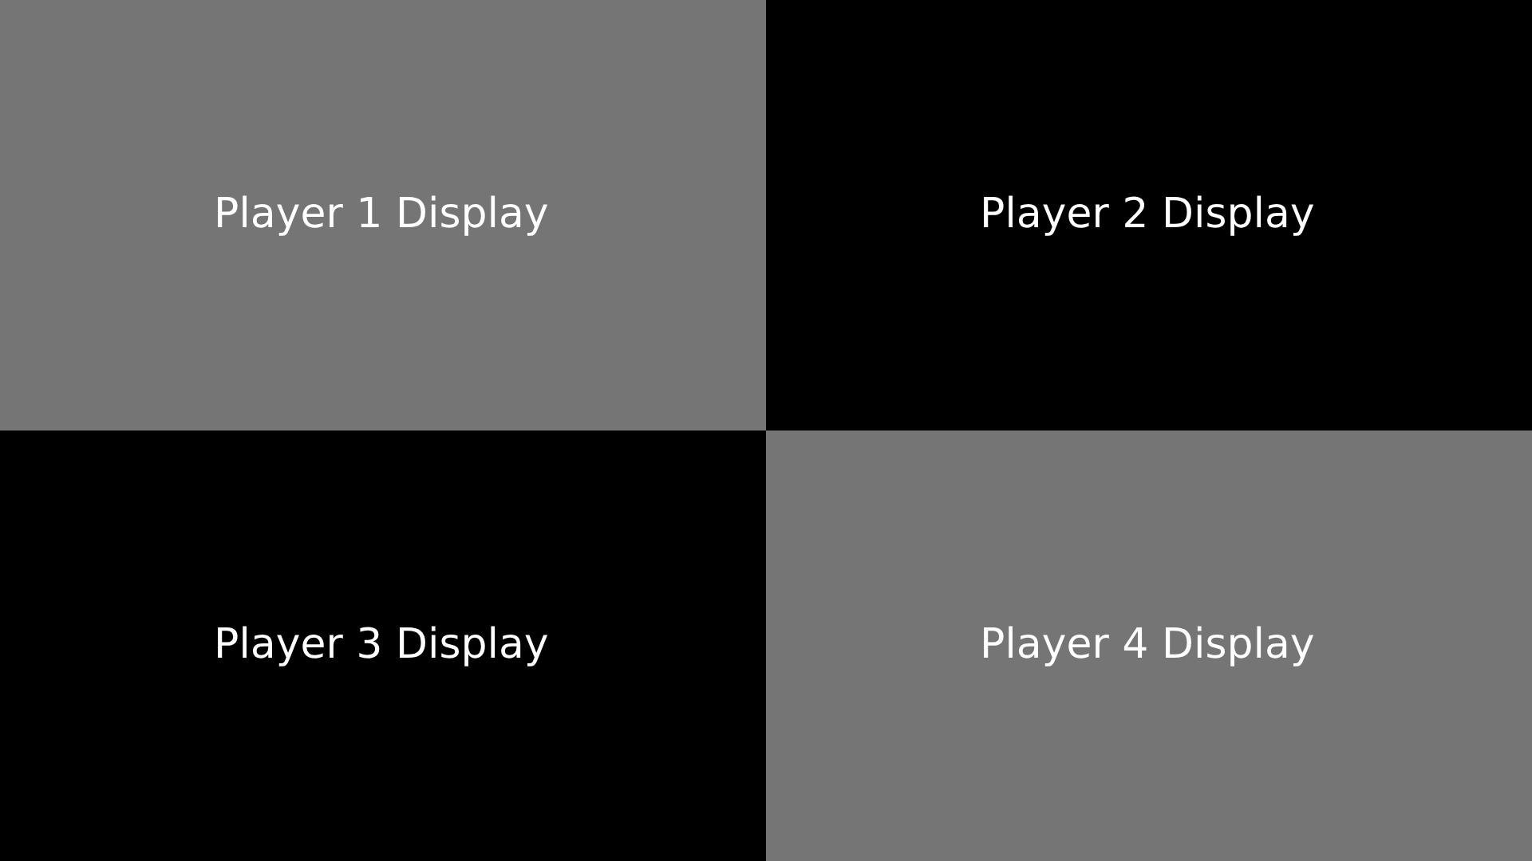
(Fig 1. The player's cameras scale the rects for a max of four equal viewports)
CameraBudget turns off views that a full-screen camera covers (cutscenes, results, the Dispatch room). The live scoreboard and prompts are screen overlays over all the views. Display settings live in settings.cfg and are applied by DisplaySettings using the pure rules in DisplayRules, in builds only.

Match Flow
GameManager holds the game state and raises a swap event for each one. Note that the main round plays in Begin, not MainLoop: MainLoop only flashes inside the opening cutscene, and Paused is never applied (pause is PlayerInstantiate.IsPaused). Anything that must run during the match keys on Begin until OnMainGameFinishes.
State | What happens
Menu, Options, Credits | Title screen and its pages
PlayerSelect | Local player select, or Dispatch online. New-match reset runs here
Loading | Loading screen, held scene load
StartingCutscene | Opening cutscene
Tutorial | Local matches only. A skip hands over driving, then goes straight to Begin
Begin | The waves. Then whistle, highlight reel and load of the final area
GoldenCutscene | Golden round opening
FinalPackage | The golden round
Results | Podium, awards, rematch vote

Gameplay Mechanics

Order Game Objects
The order object is a prefab with waypoints for its pickup and dropoff, set by designers per order in the scene. Difficulty is Constants.OrderValue: Easy, Medium, Hard or Golden. Those enum numbers only name the tier, because scenes store them. Do not change them: money comes from StealValueRules. The main scene holds 28 orders and FinalAreaScene holds the golden order. On every machine an order is identified by OrderBook: a hash of scene, value, pickup and dropoff.

Order Manager
OrderManager runs the pool. Each wave has authored caps (maxEasy, maxMedium, maxHard: 1/1/0, 2/1/1, 1/1/2) and spawns one order every cooldownTime (4 s) while there is room, at random (randomizeWaves). Delivered orders go to the back of the list. waveLengthInSeconds (60) is scaled by HouseRules.WaveFactor. When a match plays more or fewer waves than were authored, WaveTable spreads the rows over them. GoldRushRules multiplies quotas by 3 and shortens the cooldown. The golden order has a special reference and isn't part of the regular list.

Golden Order
When the waves end, OrderManager plays the reel if there is one (HighlightDirector.ReelThen) and then loads the final area. While held, the order's value rises by goldIncrementValue (5) every goldValueTimer (2.5 s), stopping just over 999. Delivery pays the base value, and AwardGoldenBonus adds the difference. goldenOrderMultiplier (0.85) reduces the holder's force. Otherwise it behaves as a normal order. A golden holder who leaves online puts it back at its start and starting value through EraseGoldWithoutDelivering, without ending the round.

Holding Orders
Each player carries up to 2 orders, on 2 transforms behind the scooter (OrderHandler). Held orders ride as children of the scooter, which is why a delivery's throw and a leaving player both call Order.ReturnHome first. Once held, the compass shows the dropoff and its beacon glows for that player only, using the ball's layer + 7. It doesn't matter in what order they were picked up.

Order Arrows
Every order has an arrow pointing to its dropoff, disabled unless held. It subtracts the arrow position from the dropoff position and applies Quaternion.LookRotation with the result.

Driving
The most frequently-used mechanic, and probably the most complex, is driving (BallDriving). Each player drives a Vespa-like scooter. Driving is intended to be fun, snappy, and responsive (arcadey) rather than an accurate simulation. Input arrives through IDriveInput, so a controller, the keyboard or a bot (BotDriver) all drive the same code.

Sphere Driving
The controller doesn't technically control a scooter, but a sphere (radius 1, mass 300) that the scooter follows. This was chosen after much trial and error, as it gives the feel we're going for with minimal difficulty.
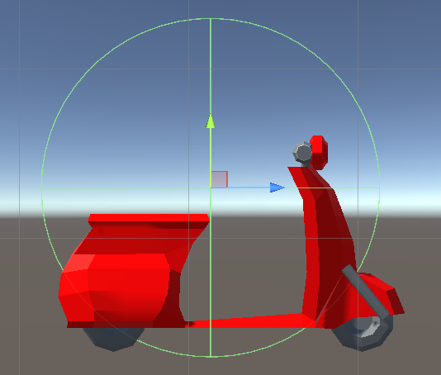
(Fig 2. Scooter object in editor highlighting the sphere the player controls)

Acceleration/Braking
Acceleration is controlled by the right trigger on the controller. Braking is controlled by the left trigger. Using Unity’s new input system, the triggers will be read as axes rather than a single button press, allowing for more precise control.
Acceleration will be applied to the sphere by calculating the force applied to the sphere, modeled by the equation
$F = p_{a} t_{r} - p_{b} t_{l}$
- $F$ is the force applied to the sphere
- $p_{a}$ is the configurable constant representing acceleration power
- $t_{r}$ is the input from the acceleration (right) trigger (ranging from 0 to 1)
- $p_{b}$ is the configurable constant representing braking power
- $t_{l}$ is the input from the braking (left) trigger (ranging from 0 to 1)

If $p_{a} t_{r}$ exceeds $p_{b} t_{l}$ then the sphere will accelerate forwards. If the opposite is true, it will accelerate backwards. And if they’re both zero, the sphere will not move. This is a simple way to control movement forwards and backwards. To note, we will be using Unity’s built in physics systems for moving the sphere rigidbody.
Force is only applied if the scooter is on the ground, as determined by a quick raycast. That raycast is also used to match the scooter model’s parent’s rotation to the slope of the surface it’s on.
On top of this base, the frame's force adds drift, boost, slipstream and boost pad bursts, then multiplies by grass (0.65), the golden order (0.85) and the Speed mutator (MatchPhysics.SpeedScale).

Motion and Steering
The scooter will follow the sphere as previously mentioned. In order to steer the scooter, the force applied to the sphere is in the forward direction of an empty which is the parent of the scooter model. This empty is rotated based on the left stick input multiplied by a scaling factor. Some additional processing is applied to the stick input to roughly simulate the way that the vehicle’s speed should affect its turning circle.
The scooter model is additionally locally rotated by a small extra amount, as well as titled on its x-axis based on the amount of rotation.

Reversing
Introducing realistic reversing using a reverse gear would require including a number of concepts (tire friction, skidding, burnout, etc.) that would not only be extraneous, but reduce the arcade feel we’re aiming for.
As mentioned above, reversing will happen when $p_{b} t_{l}$ exceeds $p_{a} t_{r}$. This will optimize the driving substantially, as most of the player movement can happen with this one equation. However, some cases for reversing will have to be considered that don’t apply to normal driving:
- The steering angle of the scooter will be inverted to match player expectations
- Drifting will only be possible when the player is accelerating

Drifting
When the drift button (X on Xbox, Square on PlayStation, Left Shift on keyboard) is held, the player is flagged as drifting in the direction they're turning. If the left stick is in its deadzone, nothing changes until it moves. A DOTween punches them up into a small aesthetic hop.
- Normal steering is overridden (driftTurnScalar 1.4, driftTurnMinimum 0.3)
- The turning radius is reduced in the drift's direction, with slight adjustment the other way
- A charge builds toward 3 spark tiers (driftBoostThreshold 30)
- Releasing adds a burst to the sphere's force by tier: driftBoost1, 2, 3 = 800, 1200, 1600
- slowdownImmunityDuration (1 s) then ignores grass

Slipstream
Each scooter has a raycast going directly out of their front and back, masked to only collide with other scooters’ control hitboxes.
When the forward raycast hits a control hitbox, it uses the RaycastHit data to check if its target’s backward raycast is hitting its own control hitbox. If it is, that means that there’s a scooter directly in front of this one, and facing away. When this condition is met, and if both players are moving at a certain speed, the rear player will be flagged as drafting until the condition is no longer met.
While in this state, the player slowly gains speed. After slipstreamTime (1.5 s) they get a larger burst (slipstreamBoostAmount 270) and the duration resets. Range is slipstreamDistance (8), at above minimumSlipstreamSpeed (10). Another machine's scooter takes part too, through the velocity set in BallDriving.ShowRemote.

Phase Boosting
A boost gives a burst of speed, steals, and phases through walls. Values on PlayerAvatar.prefab: boostPower 60, boostDuration 1.6 s, boostingDrag 0.86 (overriding the sphere's drag so it can exceed top speed), boostingSteerModifier 0.6. The recharge is boostRechargeTime 3 s, or handsFullBoostRechargeTime 8 s when holding a package. A DOTween sequence plays the wheelie.

Stealing Orders
The machine driving the boosting scooter detects the hit, and OrderHandler.StealFrom runs on the authority only. It first offers the hit to ModeReferee (the timed modes use it instead), then honours HouseRules.StealsOn. GetBestOrder returns the most valuable order. A thief with a free hand takes it, and the victim drops the rest via DropEverything. The victim spins out and bounces.
StealValueRules holds every number: prices 55/65/80/50, Worth doubles per steal (never for golden, counting stops at MAX_COUNTED_STEALS 16 to prevent overflow), STEAL_PAY 7 once per order per thief seat, Swell +15% per steal up to 4. CountsIn excludes the Tutorial state. GoldRushRules.StealCounts makes a rush hour steal count twice. The stolen look is PurpleFlame, a code-drawn flipbook.

Phasing Through Buildings
During a boost, player collisions with phaseable walls are off (ToggleCollision), so the scooter passes through. The boost starts checking phase status, and two raycasts from the front and back of the scooter test whether it is inside a building. They go down onto duplicate copies of the main buildings placed below the map, because the above-ground buildings can't be raycast in this setup. When both are clear, physics collisions come back on and the boost may end. This means it is impossible to get stuck in a wall, and adjacent buildings are passed through as one.
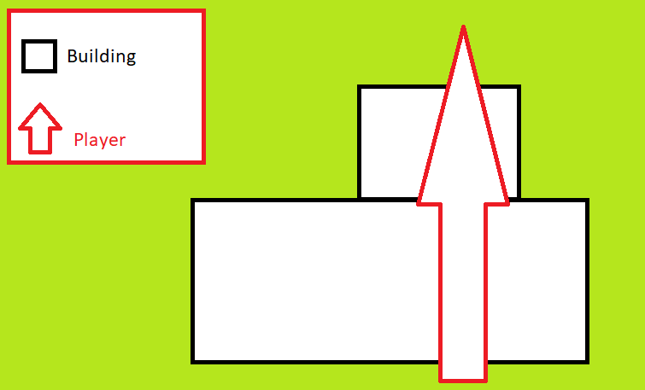
(Fig 3. Diagram showing boosting through multiple buildings)
phaseType is OnlyInBuilding. While inside, BallDriving.SwapRendering makes PlayerCameraResizer swap the view to its phase camera, which uses the Player N - Phase Renderer assets. The 2023 wireframe void and its alternate camera idea were dropped as jarring. A bot has no view, so the swap does nothing for it. Other machines hear phases through cues.

Scoring
Each OrderHandler holds its player's score and only the authority changes it (the local PC, or the host online). ScoreManager works out placings for the Scoreboard. Scores travel online on each OnlinePlayer. Gold Rush's drain (GoldRushRules.Drain) and the timed modes' points are also authority-only. Tutorial points carry into the match. Scores reset for a new match in GameManager.OnNewMatch.

Respawning
A killzone trigger or BallDriving's water check starts Respawn. RespawnManager picks the nearest RespawnPoint that nobody is using (63 in the main scene, 67 in the final area), and holds it for the respawn. RespawnPoint.PlayerFacing gives the direction. Held orders drop onto that point's order spots. The rider is hidden as a wisp, then rises from a RespawnGravestone with a sparkle after about 2 s. This replaced the 2023 raycast search for a point near the ledge. Online, the host picks: a client asks, and waits hidden up to 2 s before picking its own.

Emote System
Not in the game. EmoteHandler.cs and its sprites remain in the project, but no prefab or scene in the build uses the component, and the input asset has no emote action. Only a test still references the class. The same goes for UI/Minimap.cs.

Final Order Sequence
The golden round is a separate scene, FinalAreaScene, loaded through SceneFlow.Current.LoadFinalOrderScene behind its own loading screen. The fog reveal in the 2023 plan was never needed.

Game Modes and Match Rules
Class | Job
HouseRules | The rules: mode, length, waves, steals, golden, bots, speed, gravity, round timer. Current is what the host picked, Playing is what this match uses. A public lobby always plays Normal. Gameplay reads the effective values (StealsOn, GoldenOn, WavesPlayed). Saved in settings.cfg
ModeRules | Table of which rows each mode shows, hides or locks
RulesPanel, RulesPrompt | The MATCH RULES UI. It notes when the rules are experimental
MatchPhysics | Applies Speed and Low Gravity (-13 to -6.5), reset for the menus
GoldRushRules | Gold Rush numbers and drain
TimedModeRules | Numbers and pure rules for the timed modes
ModeMatch | Pure state of a timed match, run on the authority
ModeReferee | Authority glue. Hooked at the top of OrderHandler.StealFrom
ModeVisuals | Runs on every machine: crown, potato, infected colours, out players and spectator camera
OnlineModes, ModeSnapshot | Whole-state snapshot on every change. Each machine counts the fuse on its own clock
BotModeTactics | Bots in the timed modes

A timed mode runs as one "wave" as long as the Round Timer, which reuses the clock, time up, reel and results flow. The host shares packed rules through OnlineMatch.rules, and HouseRules.FollowHost applies them at Begin. Every choice made while building is in docs/game-modes-decisions.md.

Bots
- Online only. BotFill says how many drivers a match needs. The host seats them, host-owned, with no view
- Driving: BotDriver implements IDriveInput, so bots use the real driving code. BotBrain handles steering, throttle, boosting and backing out, on the Scooter NavMesh
- Decisions: BotTactics scores orders and steals using a BotPersonality profile (thief, hunter, courier, assigned by seat rank) and the scoreboard. BotChase limits chases. BotModeTactics covers timed modes. BotNames picks names
- Logging and tuning: BotStats logs a round. Weights are in BotPersonality
- Votes: CutsceneSkip.VotingSeats counts humans only
- Known gaps: barred victims carry across a round end, BotStats can mislabel a steal as a pickup, the courier's dodge looks up components every frame

Highlight Reel
HighlightDirector records each seat from Begin, in a ReelRecording ring (12000 samples per seat, about 3 MB in all, nothing allocated per sample). HighlightRules scores moments and picks clips, and ShotDirector picks the shots. HighlightReel plays them with stand-ins and ReelOverlay's CCTV-style text. Online, only the list travels: the host picks and shares a ReelList, and every machine plays its own recording. A client uses it only if NetChecks.Sane passes, and starts from its StartAt in server time. The host doesn't wait for any client.

Results
- Awards: MatchAwards and MatchStats count on the authority via FeatSync. AwardRules picks one per player. Online the host sends an AwardBoard once
- Rematch: RematchVote is the rules, ResultsVote the screen, 15 s (RematchVote.SECONDS). Online the host holds the vote (OnlineRematch, RematchBoard). MatchReset.ForRematch and TutorialManager.SkipNextTutorial start the next match without a tutorial. A machine taken out gets SendAway, not a ban
- Cutscene skip: SkipVote and CutsceneSkip on the same pattern, with OnlineCutsceneSkip and SkipBoard

Player Management

Player Spawning
A player is two prefabs. PlayerAvatar.prefab is the scooter every machine sees. Player - Cinemachine.prefab is a player on this machine: it nests an avatar and adds cameras, HUD and menus as overrides on its Control. Never apply those overrides to the avatar, or revert them: PlayerPrefabTests fails if either happens. PlayerJoiner joins players itself, with PlayerInputManager on manual joins, so unrelated keys make nothing. PlayerRoster and PlayerSlot track seats 0 to 3.

Player Input
Each player has one device through the Input System. KeyboardControls installs keyboard bindings in memory at launch, leaving the asset on disk unchanged. With one player on the PC, using another device switches that player to it. RebindRules and ControlsPanel handle rebinding, saved per seat in bindings.cfg. ButtonGlyph picks prompt art by device. ControllerDisconnectPolicy handles a lost pad, using user.lostDevices because DeviceLost fires before hasMissingRequiredDevices updates.

Player Score
See Scoring. The Scoreboard is built in code on a screen overlay canvas, so no scene or prefab holds it, and its sizes are constants at the top of the class. GhostPortrait renders each couch player or bot to a picture, stopping after 3 frames. SteamAvatars supplies Steam pictures for one player per machine.

Online Multiplayer

Architecture
Peer-hosted: one player's game is the host and the authority for orders, scores, the clock and game states. Each machine drives its own scooter. Netcode's scene management is off, and there is no Netcode object per order. Local play runs none of this. GameAuthority says who decides. A client changes orders only while replaying a host change (OrderSync).
Piece | Job
OnlineSession | Hosts or joins. Steam (HostSteam, JoinSteam) always, direct IP (HostDirect, JoinDirect) in editor and dev builds only. Reports why a session ended
JoinRules, LobbyRules | Same build, free seat, host in menus. Build tag is version + Netcode config hash
OnlineLobby, ILobbyService, Matchmaker | Lobby flow in plain C# over fakeable services. Lobbies are friends-only until Fill. Find searches, picks by fullness and ping (MatchRules)
OnlinePlay | Made at launch. Owns the lobby and answers invites
OnlineGame | The game's side of a session: role, scene flow, seats, relaying states. Adds the Online* glue components
SeatTable | Seats by machine. OnlineRules.OnePlayerPerMachine is true: couch online is built but off, and tests set it false
OnlineMatch, OnlinePlayer, OnlineScooter | The three network prefabs. OnlinePlayer has seat, look, name, Steam ID, score, ready. Run Save Network Prefab IDs after changing them
OnlineSceneFlow, LoadRound | The host starts each load, counts who's ready and shows the scene together. A held load can't be cancelled
HostQueue | A client's host messages wait while its scene changes, keeping order
RemoteAvatar, ScooterLook | Another machine's scooter, dressed by path, with controls and physics off

What Syncs and How
Thing | How
Scooter pose | Two proxies on OnlineScooter, moved by owner (OwnerNetworkTransform), plus DriveFlags. A move over 10 m jumps. OnlineDriving applies them
Game state | Ordered RPCs on OnlineMatch
Clock | Host's end time in server time (MatchClock), bells via ClockCue
Orders | OrderChange RPCs replayed through game code (OnlineOrders)
Steals, clashes | Owner asks (StealSync). StealRules judges: reach 50 m, pair cooldown 2 s. PlayerHit tells all
Bumps | BumpReporter, BumpRules, PlayerBump. One per pair per 0.5 s, no harder than a clash
Respawns | RespawnSync asks, host holds a point, OnlineRespawns answers
One-shot sounds and effects | ScooterCue through CueSync and OnlineCues. RemoteSound sets volume by distance
Achievements | Host sends by seat, each client unlocks only its own
Pings | PingBoard every 2 s (OnlinePings)
Timed modes | ModeSnapshot (OnlineModes)

Online Safety
Threat list and measures are in docs/online-safety.md. In short: connections only from lobby members (ConnectionGate in the patched transport), relay-only so IPs don't leak (SteamRelay), per-sender rate limits with kick (RateGate), checks on everything the host sends (NetChecks), cleaned names and reasons (PlayerNames, LobbyRules.Shown), and no direct IP sessions in release builds. Lobby search results are untrusted. Movement cheats are out of scope for now.

Steam Integration
- App ID 5553880. Depots: Windows 5553881, macOS 5553882, Linux 5553883. tools/set-app-id.py changes all of them
- SteamManager starts Steam at launch (before the first scene). SteamStartup holds the ID. Without Steam none of the features call Steamworks
- Achievements: 9, in MatchFeats and FeatSync. Rich Presence: PresenceRules, and keep docs/steam/rich-presence-english.vdf in step. Opt-in logs: -sessionlog (SessionLog)
- Cloud syncs settings.cfg only
- Steam Input gotcha: Steam can take controllers from Unity while the app runs. Check Steam's logs/controller.txt first. Default config Gamepad is still to set in Steamworks
- Steam Deck notes are in docs/steam/steam-deck.md

Localization
Own system: Loc reads Assets/Resources/Localization/strings.csv, generated by tools/strings.py from tools/strings_en.py and strings_tr.py. Do not edit the CSV by hand. A key missing from strings_en.py gets dropped, and StringsCsvTests needs each key translated. LocalizedText updates text live. LanguageRules picks Steam's language, then the PC's, then English. AccentOverlay draws marks the fonts lack. DrawnWords replaces hand-lettered sprites outside English. HostNotice sends host messages as keys so each player reads them in their own language. All translations are machine-written and need a native check before release.

Settings Files
In %USERPROFILE%\AppData\LocalLow\The Boo Crew\Dead on Arrival\: settings.cfg (one key=value per line, GameSettings) and bindings.cfg (per seat). The full key list is in docs/controls.md. OptionsBook and OptionRow build the code-made option rows. Comfort applies Reduce motion, Colourblind holds the safe colours and badges, and TextSize scales every TMP text from its text-changed event.

World Mechanics

Boost Pads
Booster: a collision trigger that gives extra force (groundBoostDefault 160). 14 SpeedBoost prefabs in the main scene and 15 in the final area, updated by BoostPadManager.

Grass
A trigger that sets a flag, multiplying force by slowPatchMultiplier (0.65) unless boosting or immune.

Moving Objects
MovingPlatformGroup prefabs in both match scenes. The 2023 Barriers and MovingPlatform scripts are in Scripts/OUTDATED and unused.

Pedestrians and Props
PedestrianManager and CivilianAgent run pedestrians on a NavMesh, animating only when on screen. Kickable and CanKicker handle props. These run separately on each machine, reacting to all scooters.

Scene Management

Persistent Scene
Alex Player Testing is the menu scene: it holds the managers and players, which persist through matches. Play only works from SplashScreen, as the managers live here. The game has its own class named SceneManager, so fully qualify Unity's as UnityEngine.SceneManagement.SceneManager.

Asynchronous Loading
Scenes load asynchronously and held, behind a loading screen, through ISceneFlow (local or online). The build holds these scenes:
- SplashScreen
- Alex Player Testing: menus, players, managers
- Design Scene(Main): the main map
- FinalAreaScene: the golden round
- Tutorial scene
- Multiplayerlobby: the Dispatch room, loaded additively (DispatchRoomLoader). The game's SceneManager ignores additive loads
Each map scene is large, and a cold editor load can take over 40 s, which is why direct sessions use a 90 s timeout (OnlineSession.DIRECT_DISCONNECT_MS).

VFX and Shaders
The look uses OToon on URP, with renderer features per player: SSAO, object outlines, decals, the anime speed lines, custom vignette, and a pair of through-wall features (PlayerHidden, Player Visible) that silhouette players behind walls. Each player has a Player N - Main Renderer and Player N - Phase Renderer. The Main Volume has both Bloom and BenDayBloom, and combining them is a listed performance option. The Hi-Fi Rush reference below drove the bloom dot and cross hatch style.
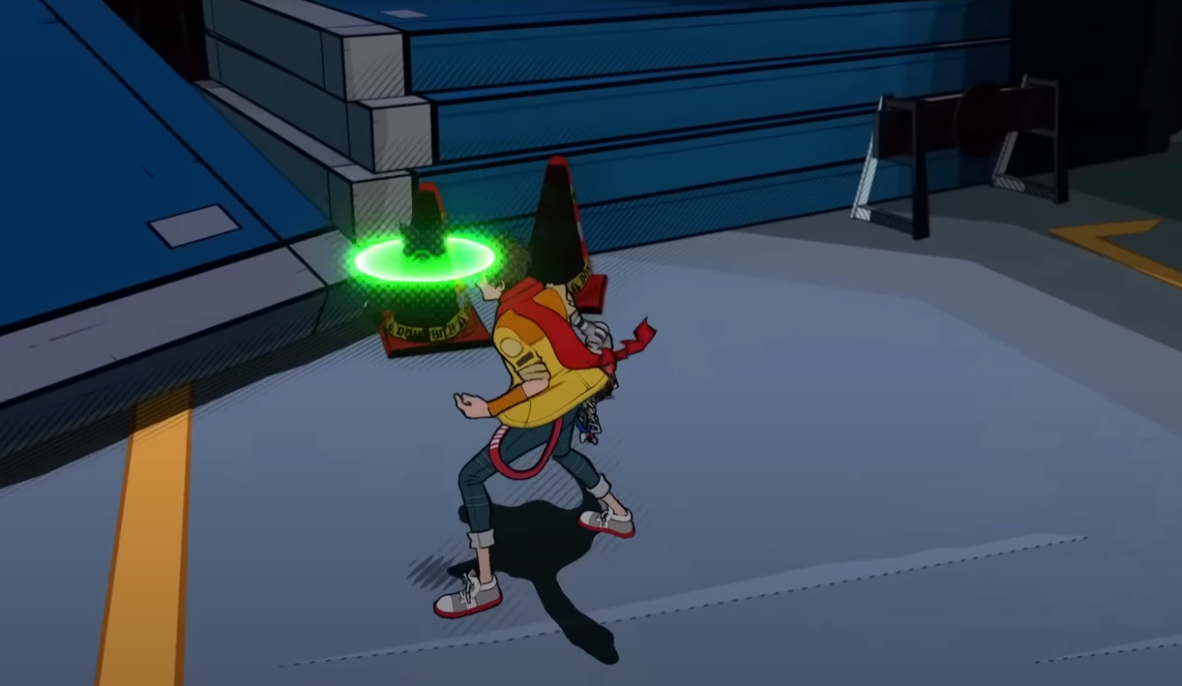
(Fig 4. Reference: these effects are implemented very noticeably in Hi-Fi Rush)
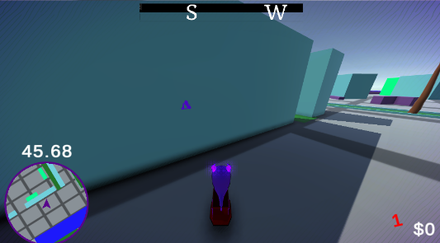
(Fig 5. Silhouette of a player on the other side of this wall)
Other effects: the boost trail, the death wisp, package beacons and effects, water and vertical fog shaders, and the code-drawn purple flame. The golden order's glow comes from Order's per-tier tables. BloomFX was fixed for Metal in the macOS build.

Player Trails
TrailHandler uses a Trail Renderer behind the player when boosting. Trails grow and shrink rather than pop, using a coroutine to lerp the trail's time up from 0 when the boost starts and back down when it ends. Drift shows sparks by tier and SkideeSkidoo draws skid marks.
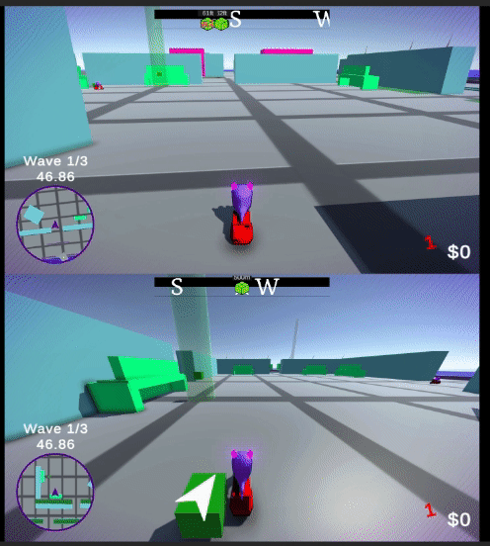
(Fig 6. Showcase of boost trail growth and shrinkage)

Sound and Audio
SoundManager is a singleton with a music source, an intro-aware loop by timeSamples, and a mixer. Each scooter has a SoundPool for overlapping SFX. Another machine's scooter only plays one-shots (no engine hum) through SoundPool.PlayRemote, at RemoteSound volume, since all the game's sounds are 2D. BackgroundAudio handles mute while unfocused. 14 placeholder sounds in Assets/Audio/TEST still play, and must be replaced before release.

Cinematics
Cinemachine and Timeline drive the opening and golden cutscenes through CutsceneManager, which locks driving until they're done. A cutscene stops when a load starts. On a client, a cutscene ends on the state it hands over to (Tutorial or FinalPackage), not on any other state: the opening plays on through a MainLoop flash. The podium uses ResultsMovementController.

Performance
- PerfOverlay (F6) and a Perf: log line every 30 s
- GraphicsQuality sets levels by quality and local player count, adjusting URP settings at runtime and restoring them on quit
- CameraBudget stops unused views
- The HitchProbe test writes long-frame markers to Logs/hitches.txt
- The ranked list of editor changes still to try is in docs/performance.md. Renderers are still Deferred, with depth priming on
- Scripting backend is Mono. IL2CPP is on the list to test
- Unused art is listed by tools/unused-assets.py in docs/unused-assets.md (about 1.2 GB)

File Structure
- Assets: all game assets
  - Scenes
  - Scripts, about 46,000 lines:
    - Player: driving, bots, input, cameras, respawn
    - World: orders, beacons, props
    - Management: managers, rules, modes, physics, settings glue
    - Online: sessions, lobby, sync
    - Steam: achievements, presence, logs
    - Highlights: reel
    - Localization: language system
    - Menu: menus, pause, options, results
    - UI: HUD, scoreboard, compass, Dispatch
    - Editor: builders and build menu
    - OUTDATED: old scripts, unused
  - Tests/Editor
  - Prefabs, Materials, Models, Textures, Sprites, Rendering, Fonts, Animations, Plugins
  - Audio: Music, SFX, TEST (placeholders), Audio Objects
  - Scriptable Ojects: Company Information, Player Colors, Player Hats (the folder name's spelling is as committed)
- Packages: including the patched Steam transport
- docs: per-system notes, Steam store and upload files, plans and specs
- tools: test runner, compile check, art and string generators
- EDITOR-TODO.md: manual editor and playtest steps, LICENSES.md: asset licence status

Hot Keys
Keys go through DevTools.GetKeyDown, working in the editor, and in a build only with the -devtools launch option. A test fails if a script reads debug keys any other way. Add any new key to docs/dev-hotkeys.md.
Key | Function
F1 | Adds a virtual test controller
F2 | Presses A on every test controller
F3 | Unplugs or replugs the newest test controller
F4 | Cycles graphics quality
F5 | Respawns every player
F6 | Frame rate overlay
F9 | Skips the tutorial
1 / 2 | Previous / next wave
4 | Loads the game scene
5 | Jumps to wave 3
Y | Deletes every active order
P | Pauses / resumes the wave timer
L | Skips the cutscene. On the main menu, removes all joined players
B | Refills every player's boost
T | Every player drops their orders

Testing
- About 1,500 EditMode tests in 218 test files. Pure rules (for example StealValueRules, ModeMatch, BotTactics) run without Play Mode
- LocalMatchSmokeTest plays a 4-player match with virtual controllers. Network tests host and join on loopback, each class on its own port (next free: 7838)
- bash tools/run-tests.sh [filter] runs them in a mirror copy, so it works while the editor is open. Only one run at a time: there is one mirror. It runs with graphics, since -nographics crashes URP
- python tools/compile-check.py compiles everything without Unity in about 30 s
- Full notes: docs/testing.md

Coding Guidelines

Classes
Classes will be named in PascalCase
Example:

Variables
Most variables will be named in camelCase.
Example:

Constants
Constants will use CATERPILLAR_CASE.
Example:

Getter/ Setter Methods
Unless absolutely necessary, don’t use public variables. Instead, use private or protected variables with getters/setters.
Example:

Serialize Field and ToolTips
If you need to have a variable accessible in the editor, use [SerializeField].
For every exposed variable, a [ToolTip] is required.
[Header]s aren’t strictly necessary, but for scripts with a lot of exposed variables they should be used.

Method Summary
All methods should have a summary detailing their functionality, parameters, and returns if applicable.
Example:
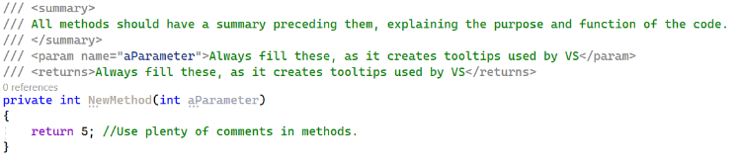

Whitespace
Avoid overuse of whitespace, one or two lines should be enough.

Coroutines
Coroutines should be held in variable names, with the naming structure of *coroutineMethodName*Coroutine.
Example:
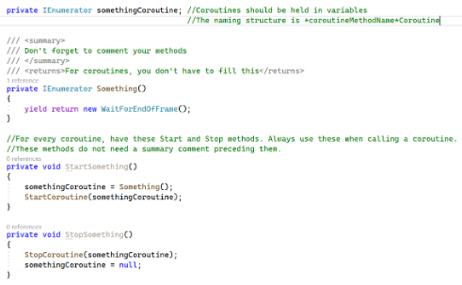
Coroutines should have individual methods to start and stop them to avoid multiple instances of the same coroutine running. For these methods, a summary isn’t necessary.

Testable Rules
Added since 2023: keep rules in plain static classes with no Unity scene dependency (the *Rules classes), so tests can reach them. Keep every tuning number in one place, at the top of its rules class. Tests reach game internals through internal members (Assets/Scripts/AssemblyInfo.cs). Existing files may be CRLF: keep their line endings.

Full Example Code
Below is the entirety of the example code for your own reference:
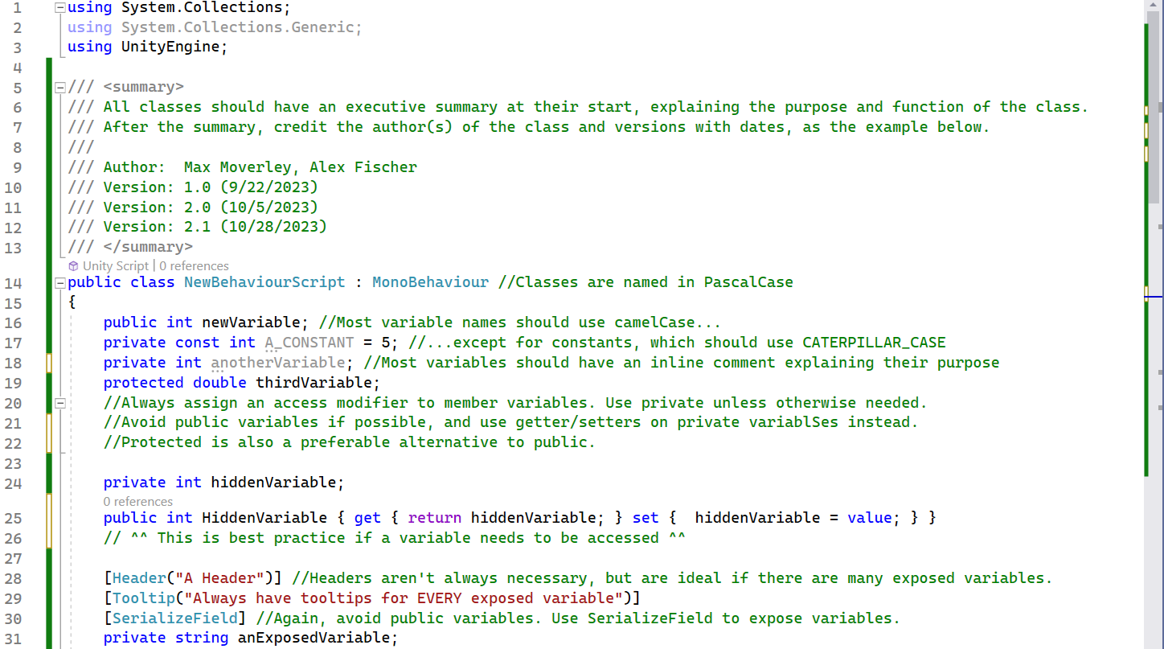
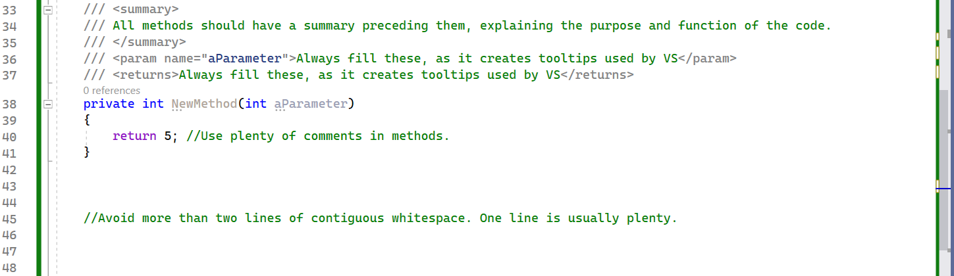
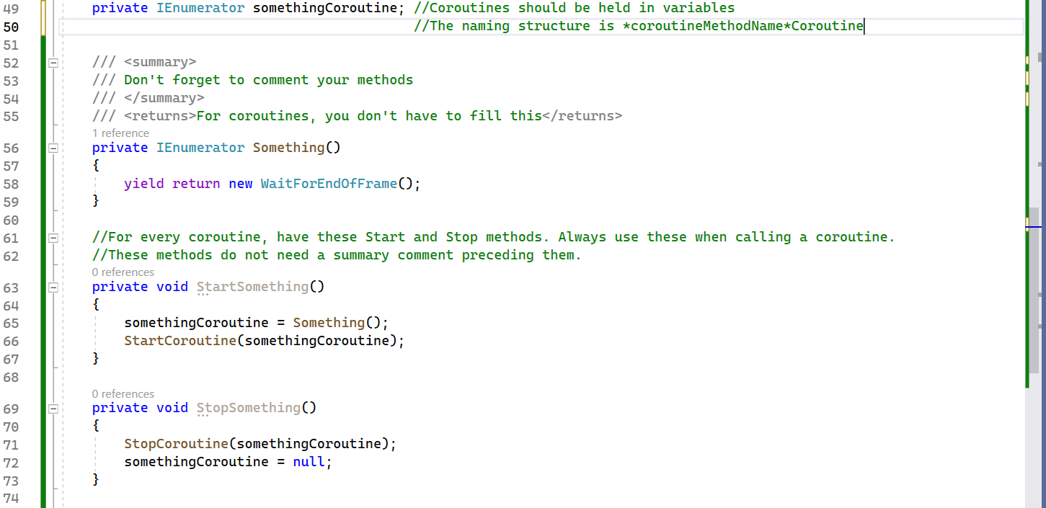
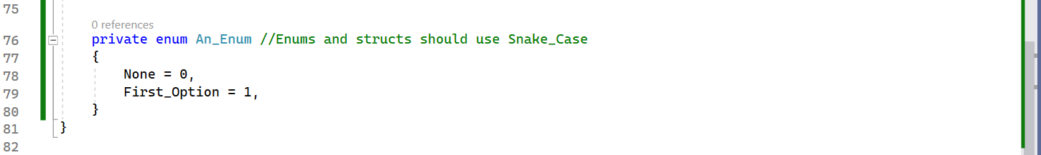

Build Delivery Method
- Tools → Dead on Arrival → Build makes Windows, macOS (Universal) and Linux builds (PlatformBuilds), into Builds/
- docs/steam/steampipe/app_build.vdf and steamcmd upload the three depots
- The build is then set live on the default branch in Steamworks
- The 2023 weekly Sunday turn-in and Wednesday build schedule ended with the capstone

Repo Policy
- Upstream is alexfish3/CapstoneYear4; the Steam work is on the Fatcats2011 fork
- main holds only the Steam API integration for now. All other work goes on steam-phase1a. Don't check main out in the editor's folder
- The 2023 Programmer and Designer branches are no longer used
- After a script builds or changes a network prefab, run Tools → Dead on Arrival → Online → Save Network Prefab IDs

Related Documents
Document | Covers
GDD (separate document) | What the game is, rules and values as design
docs/controls.md | Controls, options, settings.cfg keys
docs/online.md, docs/online-safety.md | Online in full detail
docs/player-prefab.md | Player prefab editing
docs/performance.md, docs/testing.md, docs/dev-hotkeys.md | As named
docs/game-modes-decisions.md | Choices made building the modes
docs/steam/ | Store draft, Steam features, Deck, uploads
docs/superpowers/ | Plans and specs by date

Revision History
Version | Date | Change
1.0 / 2.0 | November 2023 | Capstone technical document (IASC 4F03)
3.0 | November 4, 2026 | Brought up to date with the Steam build: engine upgrade, online, Steam, bots, modes, reel, localization, performance, tests, new build and repo process. Removed what is not in the game (fog reveal, wireframe camera, emotes, ScoreManager array plan)

